Experiment No.: 12
Experiment Name: Port Scanning Tools
Aim: To perform port scanning using Nmap in Ubuntu.
Procedure:
- Open the Ubuntu Terminal.
- Check the Nmap version using nmap --version.
- Perform a TCP connect scan using nmap -sT 127.0.0.1.
- Perform a fast port scan using nmap -F 127.0.0.1.
- Scan ports 1 to 30 using nmap -p 1-30 127.0.0.1.
- Perform a SYN scan using sudo nmap -sS 127.0.0.1.
- Observe and record the scan results.
Screenshots:
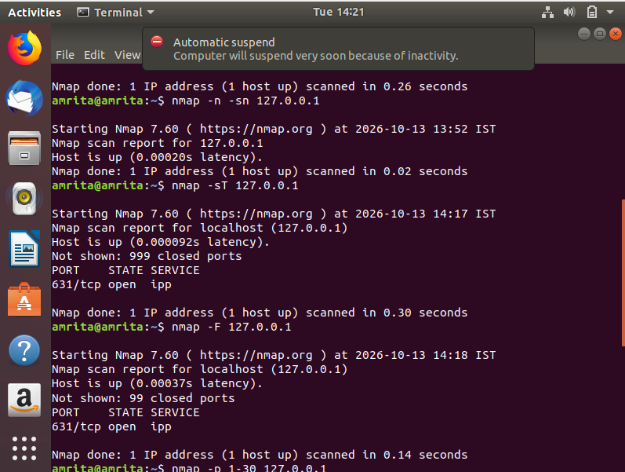
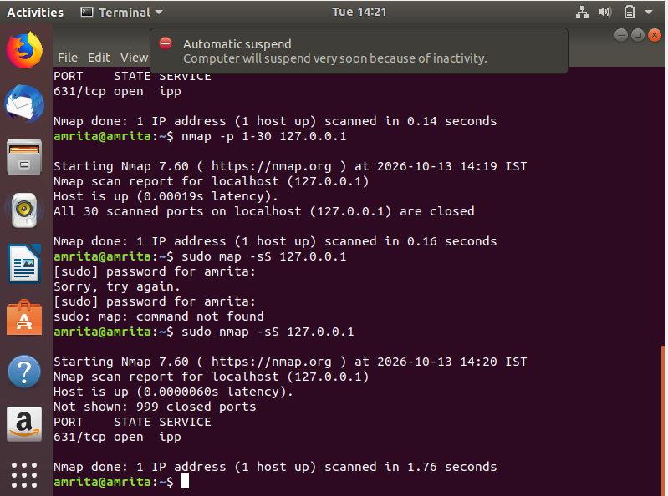
Result: Port scanning was performed successfully using Nmap in Ubuntu, and different scanning techniques were studied.

